**Q1: Examine the commands like tcpdump, netstat, ifconfig, nslookup and traceroute. Capture ping and traceroute PDUs using a network protocol analyzer.**

**Ans: Capture network traffic using tcpdump**

1. **Command**: **(a) sudo tcpdump icmp**

**(b) sudo tcpdump -i any**

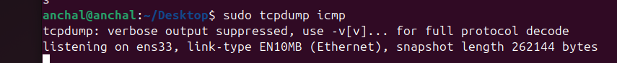

* **To View network connections**

1. **Command : netstat -tuln**

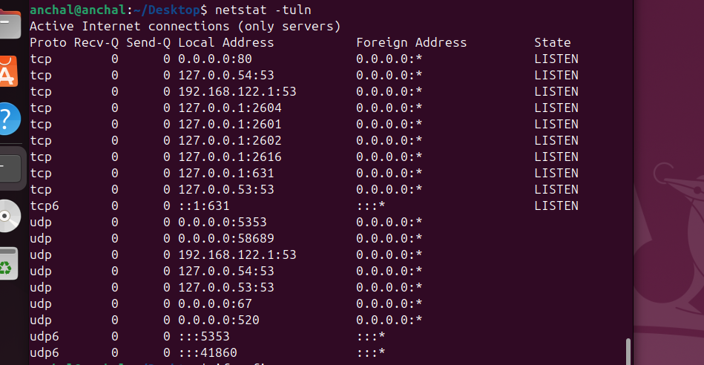

* **Check IP and network interface details**

1. **Command: ifconfig**

**You can run this command in your Command prompt and get the output.**

* **Query DNS information**

1. **Command: nslookup google.com**

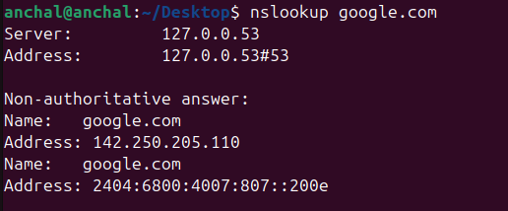

* **Trace the route packets take to a network host**

1. **Command: traceroute google.com**

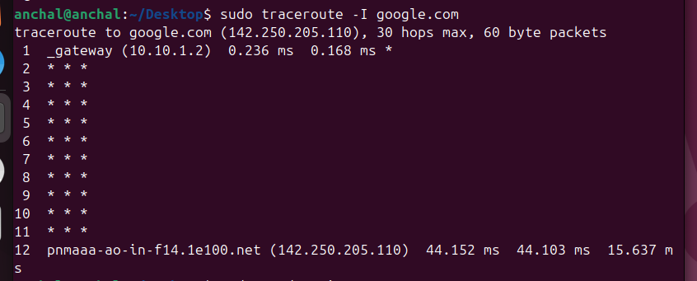

* **Ping Command:**

